Abstract title – Style AbstractTitle – is not capitalized

Ann Author and Bill F. Presenting-Author* (style Authors)

Affiliation, City, Country (style Address)
*email.address@address.ss (style Abstract)
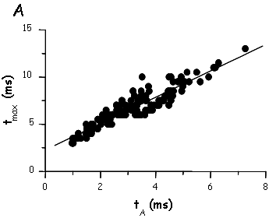
Fig. 1. Title of the figure. Description of the figure.
The text is justified, Times New Roman 12 pt, single spacing (style Abstract). Tables (Tab. 1; style TabLegend) and figures (Fig. 1; style Legend) may be included. Printed version will have only greyscale figures, the PDF version will have colour figures. Abstracts will be printed 1 per A4 page, therefore they must not be longer than 1 page but they may be shorter. Margins are 4 cm on the left side and 2.5 cm on the other sides. Please observe the style of references and cite them at the appropriate place (Name1 et al., 2008). Use abbreviated journal names.
The text is justified, Times New Roman 12 pt, single spacing (style Abstract). Tables (Tab. 1; style TabLegend) and figures (Fig. 1; style Legend) may be included. Printed version will have only greyscale figures, the PDF version will have colour figures. Abstracts will be printed 1 per A4 page, therefore they must not be longer than 1 page but they may be shorter. Margins are 4 cm on the left side and 2.5 cm on the other sides. Please observe the style of references and cite them at the appropriate place (Name1 et al., 2008). Use abbreviated journal names.
Tab. 1. Title of the table.
 | Col 1 | Col 2
Row 1 | 1 | 2
Row 2 | 3 | 4
Row 3 | 5 | 6
Description of the table.
The text is justified, Times New Roman 12 pt, single spacing (style Abstract). Tables (Tab. 1; style TabLegend) and figures (Fig. 1; style Legend) may be included. Printed version will have only greyscale figures, the PDF version will have colour figures. Abstracts will be printed 1 per A4 page, therefore they must not be longer than 1 page but they may be shorter. Margins are 4 cm on the left side and 2.5 cm on the other sides. Please observe the style of references and cite them at the appropriate place (Name1 et al., 2008). Use abbreviated journal names.
References

Name1 A, Name2 BC, Name3 D. Title. Journal 123: 123 – 133, 2008

